**How-To Run our Needleman-Wunsch Algorithm**

1. Download our folder
2. Run the GUI.py file

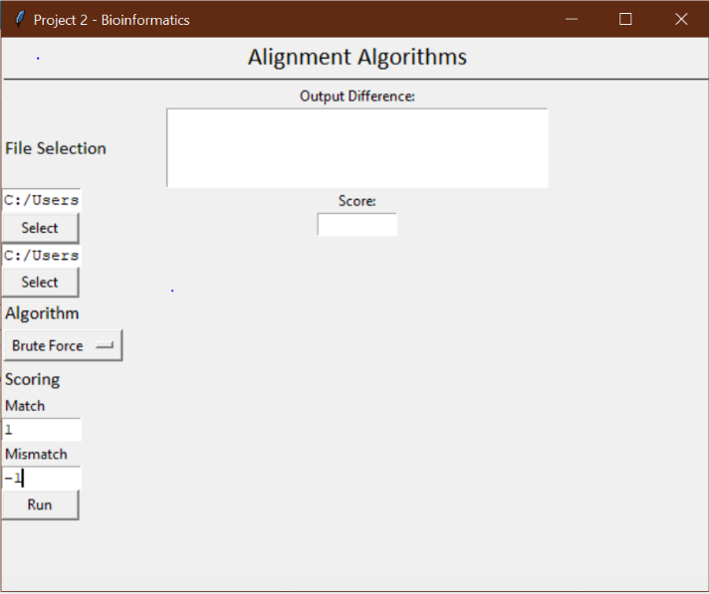

1. Select two files containing DNA sequences using the GUI’s file selector.
2. Select which algorithm you want to score the sequences.
3. 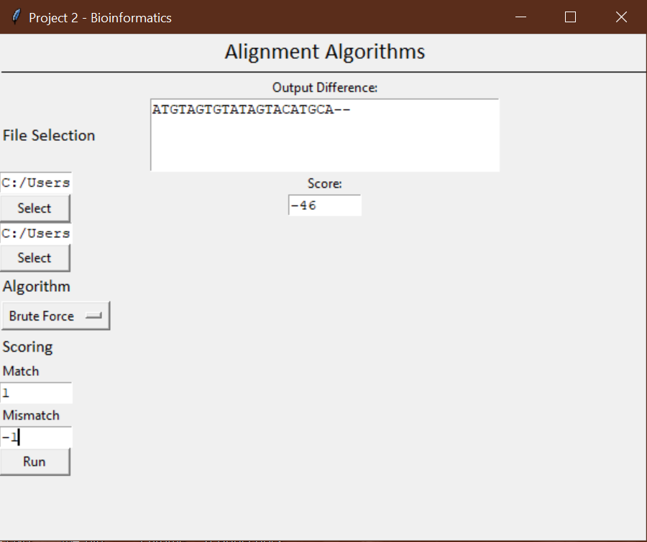Press “Run” and view the resulting output!